- 5 SCENARIO-BASED QUESTIONS ON ELIF CONDITIONS

1. Online Shopping Discount
A shopping website gives:
20% discount if total amount ≥ 5000
10% discount if total amount ≥ 3000
No discount otherwise
Write a Python program using if–elif–else to calculate the final payable amount.
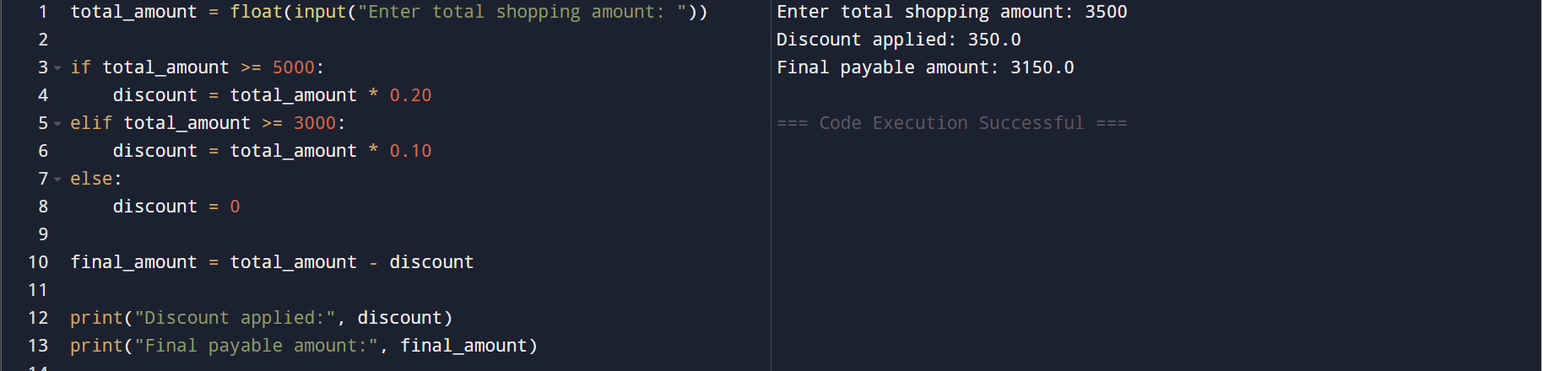

2. Traffic Signal System
A traffic light system works as follows:
"RED" → Stop
"YELLOW" → Get Ready
"GREEN" → Go
Write a program using elif to display the correct instruction based on the signal color entered by the user.
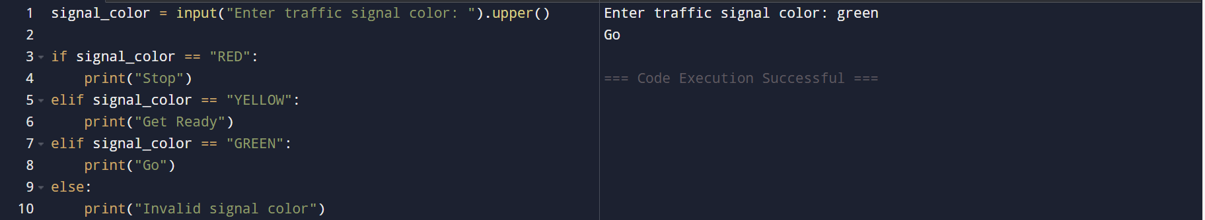

3. Electricity Bill Calculation
An electricity board charges:
₹1.5 per unit for first 100 units
₹2.5 per unit for next 100 units
₹4.0 per unit for units above 200
Use elif to calculate the electricity bill for given units consumed.
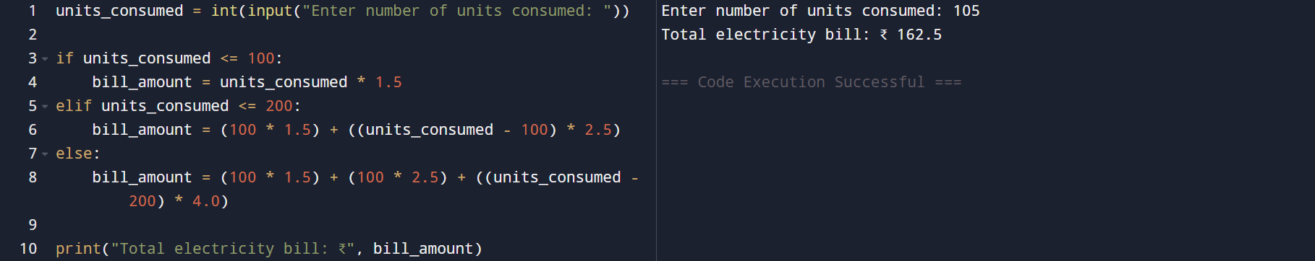

4. Student Result Processing
A school decides grades based on marks:
≥ 90 → Excellent
≥ 75 → Very Good
≥ 60 → Good
≥ 40 → Pass
Below 40 → Fail
Write a program using elif to print the student’s grade.
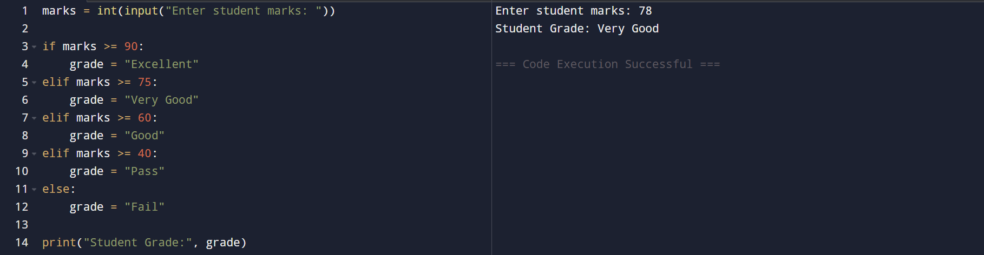

5. Bank Account Status
A bank categorizes accounts as:
Balance ≥ 100000 → Premium
Balance ≥ 25000 → Gold
Balance ≥ 5000 → Silver
Below 5000 → Regular
Write a program using elif to display account type.
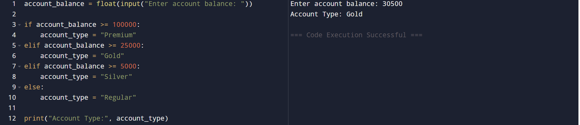

- 5 QUESTIONS ON WHITESPACES, INDENTATION, AND STRING MATH EXPRESSIONS

1. Whitespace & Readability
The following code runs without error:
Python
x=10+5*2
Rewrite it using proper whitespaces according to Python style guidelines and explain why this is preferred.

Python follows PEP 8 style guidelines, which recommend:
- Spaces around assignment operators (=)
- Spaces around arithmetic operators (+, *)
This is preferred because:
- It improves readability
- Makes expressions easier to understand and debug
- Helps maintain consistent code style, especially in teams
The result of the expression remains the same, but the code becomes clearer.

2. Indentation Error Analysis
What will happen when the following code is executed? Explain why.
Python if x > 5:
print("Greater")
How should it be corrected?
This code will raise an IndentationError.
Because in Python:
- All statements inside an if block must be indented
- Python uses indentation to define code blocks, not braces {}
Since print("Greater") is not indented, Python does not know it belongs to the if block.
Corrected code:


3. String vs Math Expression
What is the difference between the output of the following two statements?
Python
print("2 + 3 * 4")
print(2 + 3 * 4)
Explain the role of strings in math expressions.
- "2 + 3 * 4" is a string, so Python prints it exactly as written.
- 2 + 3 * 4 is a mathematical expression, so Python evaluates it using operator precedence:
  - Multiplication first: 3 * 4 = 12
  - Then addition: 2 + 12 = 14
Role of strings in math expressions
Strings:
- Are treated as text
- Are not evaluated mathematically unless explicitly converted or evaluated

4. Evaluating String Math Expression
Given:
Python
expr = "10 + 5 * 2"
a) What is the value stored in expr?
b) How can you evaluate it to get the numerical result?
c) Why should you be careful while evaluating it?
a)
It is a string, not a calculation.
b)
c) eval():
- Executes any Python code inside the string
- Can be dangerous if the string comes from user input
Example risk:
Because of this:
- eval() should never be used on untrusted input
- Safer alternatives or validation should be used in real applications

5. Indentation with elif
Identify and correct the indentation error in the code below:
Python
if marks >= 60: print("Pass")
elif marks >= 40:
print("Conditional Pass")
else:
print("Fail")
Explain how indentation affects the execution of elif.
The print("Conditional Pass") line is not indented, causing an IndentationError.
Corrected code:
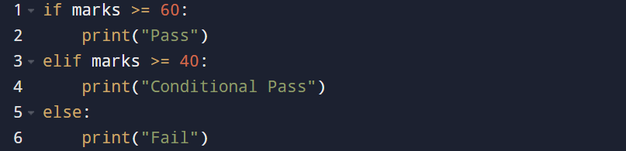
How indentation affects elif execution
- elif must align with if
- Its body must be indented consistently
- Incorrect indentation breaks the logical flow and causes syntax errors
Indentation controls:
- Which statements belong to which condition
- The entire decision-making structure

